Music Genres Classification using KNN System

- Background/ Problem Statement

Categorizing music ﬁles according to their
genre is a challenging task in the area
of music information retrieval (MIR). In
this study, we compare the performance
of two classes of models. The ﬁrst is a
deep learning approach wherein a CNN
model is trained end-to-end, to predict the
genre label of an audio signal, solely us-
ing its spectrogram. The second approach
utilizes hand-crafted features, both from
the time domain and frequency domain.
We train four traditional machine learning
classiﬁers with these features and compare
their performance. The features that con-
tribute the most towards this classiﬁcation
task are identiﬁed. The experiments are
conducted on the Audio set data set and we
report an AUC value of 0.894 for an en-
semble classiﬁer which combines the two
proposed approache
One way to categorize and organize songs
is based on the genre, which is identiﬁed by
some characteristics of the music such as rhyth-
mic structure, harmonic content and instrumen-
tation (Tzanetakis and Cook,2002). Being able
to automatically classify and provide tags to the
music present in a user’s library, based on genre,
would be beneﬁcial for audio streaming services
such as Spotify and iTunes.
One way of categorizing and organizing music is based on the genre, which is identiﬁed by some characteristics of the music such as rhythmic structure, harmonic content and instrumentation. Being able to automatically classify and provide tags to the music present in a user’s library, based on genre.
A music genre is a conventional category that predicts the genre of music belonging to tradition or a set of conventions. Categorizing music ﬁles according to their genre is a challenging task in the area of music information retrieval.
Our Music Genres Classification System will detect the music from the audio file. Once the music is detected, the system will further continue to classification. As a result, the system will display the music genre. So, for this system, there are a predefined set of music genres that the system will classify.

- Working of the Project

In this system, the user will need to register their account first to log in to the system. They can log in using their username and password. The system will detect the music genre and classify them. Once the system detects and identifies the music, the results will be then displayed to the user.
The user will only need to upload an audio file from their device. The front-end involves Html, CSS, and JavaScript and the back-end involves Python. The framework used is Django and the database is MySQL. Here, we have implemented the k-nearest neighbor (KNN) algorithm for classification.
Also, we will be using the GTZAN genre classification dataset for training our model. The type of music genres that our system will be able the classify are: blues, classical, country, disco, hip-hop, jazz, metal, pop, reggae, and rock.

- Advantages

- It is easy to maintain.
- It is user-friendly.
- The system can easily detect music and classify the music genres from the audio file.

- System Description
The system comprises 1 major module with their sub-modules as follows:

- USER:

- Registration
- The user will need to register first to log in to the system.
- The details include name, age, gender, address, phone number, and email id.
- Login
- They can then log in using their username and password.
- Genre Classification
- Upload Audio File
- The user will need to upload an audio file.
- Classifying Genre
- The system will detect the genre of the music and classify them.
- After classification the results will be displayed to the user.

- Project Life Cycle

The waterfall model is a classical model used in the system development life cycle to create a system with a linear and sequential approach. It is termed a waterfall because the model develops systematically from one phase to another in a downward fashion. The waterfall approach does not define the process to go back to the previous phase to handle changes in requirements. The waterfall approach is the earliest approach that was used for software development.

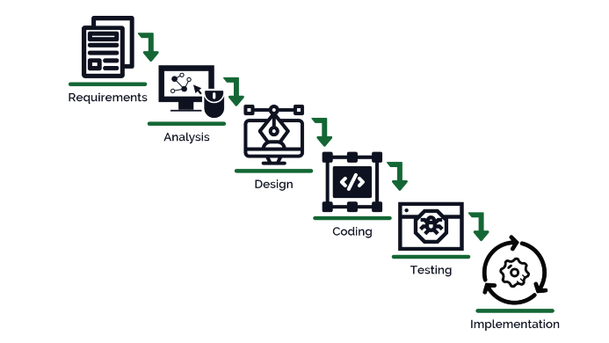

- System Requirements

- Hardware Requirement

- Laptop or PC
- Windows 7 or higher
- I3 processor system or higher
- 4 GB RAM or higher
- 100 GB ROM or higher

- Software Requirement

- Laptop or PC
- Python
- Sublime Text Editor
- XAMP Server

- Limitation/Disadvantages
- The system will detect and classify music genres only if the uploaded file contains audio, else it won’t be able to detect.

- Application – This application detects and classifies the music genre from the audio file.

- Reference
- https://www.researchgate.net/publication/324218667_Music_Genre_Classification_using_Machine_Learning_Techniques
- https://ijarsct.co.in/Paper2333.pdf
- https://towardsdatascience.com/using-convolutional-neural-network-for-image-classification-5997bfd0ede4#:~:text=The%20Convolutional%20Neural%20Network%20(CNN,suited%20for%20this%20use%20case.
- https://www.ijert.org/object-detection-from-images-using-convolutional-neural-network-based-on-deep-learning

